**Summary Document- Data Miners**

**Preface**

This is a summary document prepared by Team Data Miners as part of the final deliverable for the team project in the course “ISQA 8086- From Data to Decisions”.

**Table of Contents**

1. Introduction to the Data Set
2. Target Audience and Analysis targets
3. Research Questions
4. License
5. Metadata
6. R plots
7. Interpretation of R plots
8. References

**1. Introduction to the Data Set**

This data represented the percentage of expected death, observed deaths and potential death in different states in the United States. All data is collected based on five leading causes of death in metropolitan and non-metropolitan areas. Heart disease, Cancer, Unintentional injury, Chronic lower respiratory disease and Stroke are the major causes of death that patients are spending so much money for any treatment for them.

With analyzing this data and finding differences between Expected Deaths and Observed Deaths, health care can be improved by public health programs, that support healthier behaviors to better access the health care services for reducing the rate of potentially excess deaths.

**2. Target Audience and Analysis targets**

The potential users of this data set could be:

* Doctors who are passionate about creating awareness about causes of death and take steps for prevention of the leading causes of death
* Medicine Companies who would like to produce medicines based on the demand region
* Health Researchers’ Groups who would like to initiate programs to share the necessary information to the public for their welfare

The analysis target made by Data Miners focuses more on creating awareness in people and take necessary precautions or steps to reduce the number of deaths in future. Along with that this analysis also targets doctors to do more research on creating tools which can help in detecting diseases well in advance and to cure them once it is found. The analysis can also help Health Researchers’ Groups to conduct more programs in the regions where the number of deaths are more in number.

**3. Research Questions**

1. What is the trend of observed deaths for all the five-leading cause of deaths over time?
2. What is the trend of expected deaths, observed deaths, potentially excess  
   deaths in each age group?
3. Compare the number of deaths for various regions of US. Which region has the maximum and minimum number of deaths recorded for the years 2005 to 2015?
4. Compare the number of deaths for each locality. Which locality has the maximum and minimum number of deaths recorded for the years 2005 to 2015?
5. What is the ratio between the observed deaths and the Population? What is the trend of the ratio over time by region?
6. What is the ratio between the expected deaths and the Population? What is the trend of the ratio over time by region?
7. Are the ratios in questions 5 and 6 correlated?

**4. License:**

The License details for the Excess Deaths Data Set can be found in [License Info](https://www.cms.gov/about-cms/agency-information/aboutwebsite/privacy-policy.html)

There are no constraints on this data in regard to the license. This is public data set and can be downloaded by any individual within or outside the organization.

**5. Metadata**

This data set was collected for the years 2005-2015

**State FIPS Code** were numeric and two-letter alphabetic codes defined in U.S. Federal Information Processing Standard Publication (“FIPS PUB”) 5-2 to identify U.S. states and certain other associated areas.

**Mortality** data for U.S. residents come from the National Vital Statistics System. Estimates based on fewer than 10 observed deaths are not shown and shaded yellow on the map.

**Cause of death** is based on the International Classification of Diseases, 10th Revision (ICD-10)

Heart disease (I00-I09, I11, I13, and I20–I51)  
Cancer (C00–C97)  
Unintentional injury (V01–X59 and Y85–Y86)  
Chronic lower respiratory disease (J40–J47)  
Stroke (I60–I69)

**Locality** (nonmetropolitan vs. metropolitan) is based on the Office of Management and Budget’s 2013 county-based classification scheme.

**Benchmarks** are based on the three states with the lowest age and cause-specific mortality rates.

**Expected deaths** are the number of deaths that would be expected if the death rates of the states with the lowest rates occured across all states.

**HHS Region** is the number of the region allocated by the Office of Intergovernmental and External Affairs. It hosts ten Regional Offices that directly serve state and local organizations. A President-appointed Regional Director leads each office.

**Potentially excess deaths** for each state are calculated by subtracting deaths at the benchmark rates (expected deaths) from observed deaths.

Users can explore three benchmarks:

“2010 Fixed” is a fixed benchmark based on the best performing States in 2010.  
“2005 Fixed” is a fixed benchmark based on the best performing States in 2005.  
“Floating” is based on the best performing States in each year so change from year to year.

Page last reviewed: July 14, 2017  
Page last updated: August 28, 2017

Data Last Updated: August 15, 2017

Metadata Last Updated: August 15, 2017

Date Created: January 19, 2017

Content source: [CDC/National Center for Health Statistics](https://www.cdc.gov/nchs/)

**6. R Plots**

**Plot which represents the trend of all the five leading causes of deaths over time is shown below:**

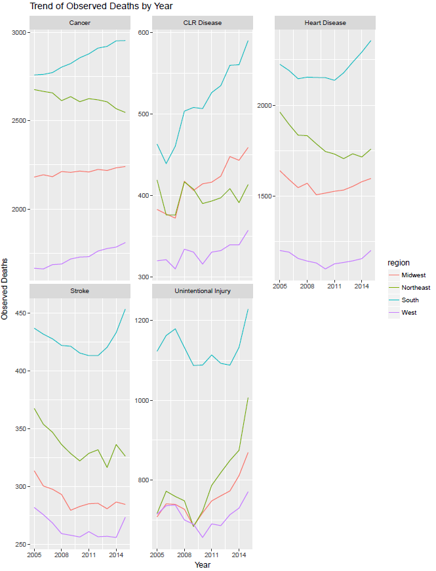

This plot provides the overview of trend for the five-leading cause of deaths (observed deaths) over time. From the plot we could see that "Cancer" has the highest number of deaths and that is in the southern region of United States. The lower number of deaths could be seen for "Stroke" in the western region of United States. The order of the trends in descending order are Cancer, Heart Disease, Unintentional Injury, Chronic Lower Respiratory Disease, Stroke.

The trend of all types of deaths in each age group is plotted as below:

A close up of a map

Description generated with high confidence

This plot provides the trend of all types of deaths for each age group. In this plot we could see that the observed deaths are always greater than the expected deaths. As the age increases the numbers of deaths kept increasing. This behavior is consistent for all the causes of death.

Plots were also developed for comparing all types of deaths averages across regions and localities as below:

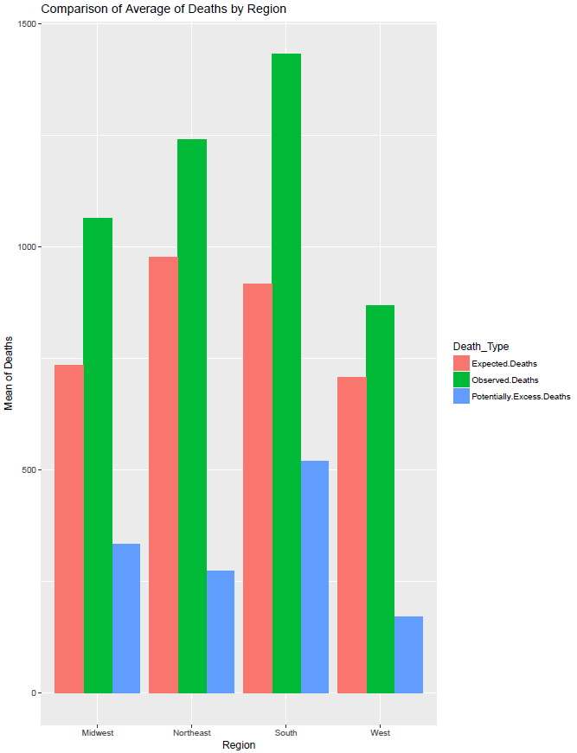

This plot gives the mean of all the deaths over various regions. The observed deaths are more in the southern part of the United States followed by Northeast, Midwest and West. The Expected Deaths average is almost equal in both South and Northeast. Midwest and West also have equal averages but lower than South and Northeast. South region also has the maximum average for potentially excess deaths followed by Midwest, Northeast and West

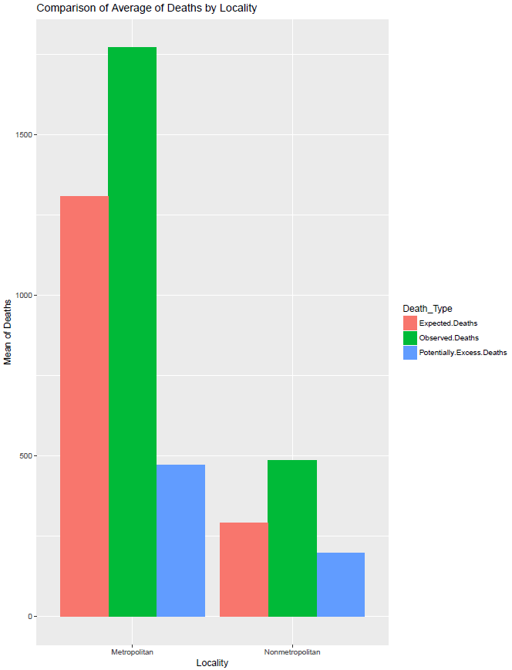

This plot provides the means of all the deaths by locality. For all the death parameters the highest and lowest are consistent which are found in All localities and Non-Metropolitan.

**7. Interpretation of R plots**

It was clear that about 85% of the U.S population lived in metropolitan localities in 2015.

**8. References**

National Center for Health Statistics. (2017, August 28). Retrieved September 04, 2017, from <https://www.cdc.gov/nchs/data-visualization/potentially-excess-deaths/index.htm>